**Assignment 7: DynamoDB Item Change Alert Using AWS Lambda, Boto3, and SNS**

**Objective:** Automate the process to receive an alert whenever an item in a DynamoDB table gets updated.

**Task**: Set up a Lambda function that gets triggered when an item in a DynamoDB table is updated and sends an alert via SNS.

**Instructions:**

1. DynamoDB Setup:

   - Navigate to the DynamoDB dashboard and create a table.

   - Add a few items to the table.

2. SNS Setup:

   - Navigate to the SNS dashboard and create a new topic.

   - Subscribe your email to this topic.

3. Lambda IAM Role:

   - In the IAM dashboard, create a new role for Lambda.

   - Attach policies that allow Lambda to read DynamoDB Streams and send SNS notifications.

4. Lambda Function:

   - Navigate to the Lambda dashboard and create a new function.

   - Choose Python 3.x as the runtime.

   - Assign the IAM role created in the previous step.

   - Write the Boto3 Python script to:

     1. Extract the modified DynamoDB item from the event.

     2. Send an SNS notification detailing the change.

     3. Log messages for tracking.

5. DynamoDB Stream:

   - Enable DynamoDB Streams on your table and set the view type to "New and old images".

   - Attach the Lambda function to the DynamoDB Stream.

6. Testing:

   - Update an item in your DynamoDB table.

   - Confirm that you receive an SNS alert detailing the change.

**Submission:**

- Provide the Python code used in the Lambda function.

- Document the steps followed.

- Share screenshots of the SNS alert and Lambda logs.

Project solution:

DynamoDB Setup:

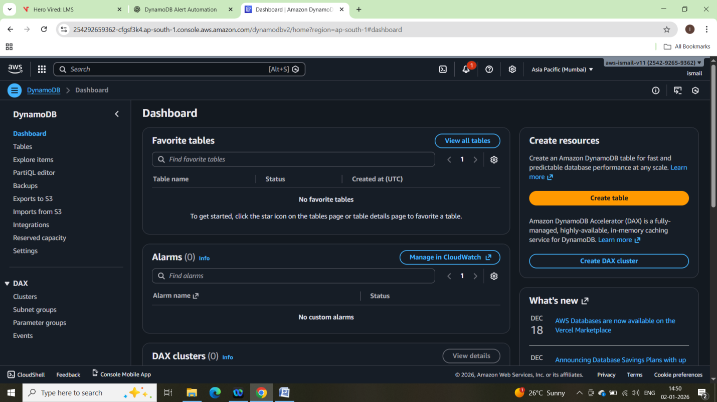

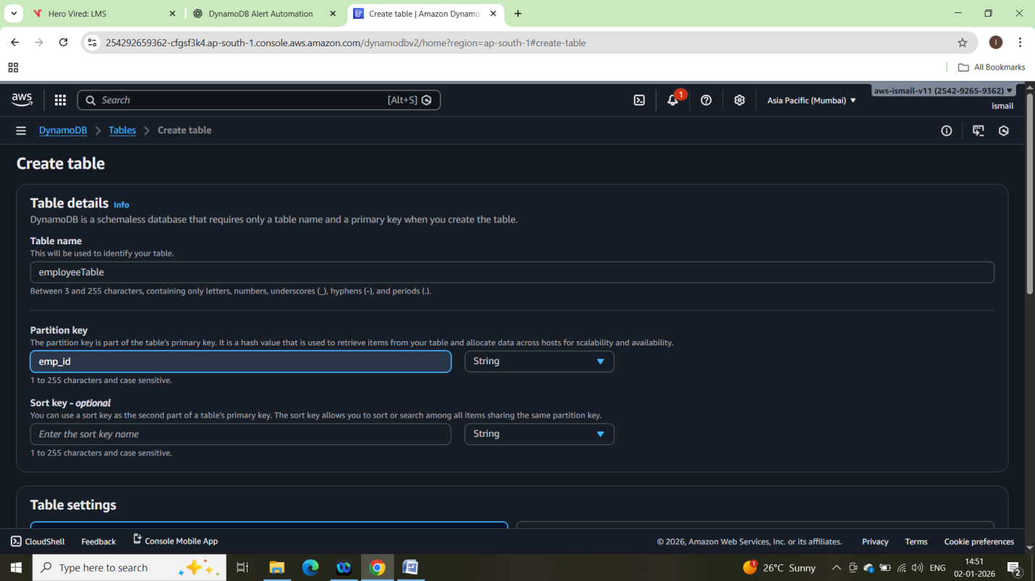

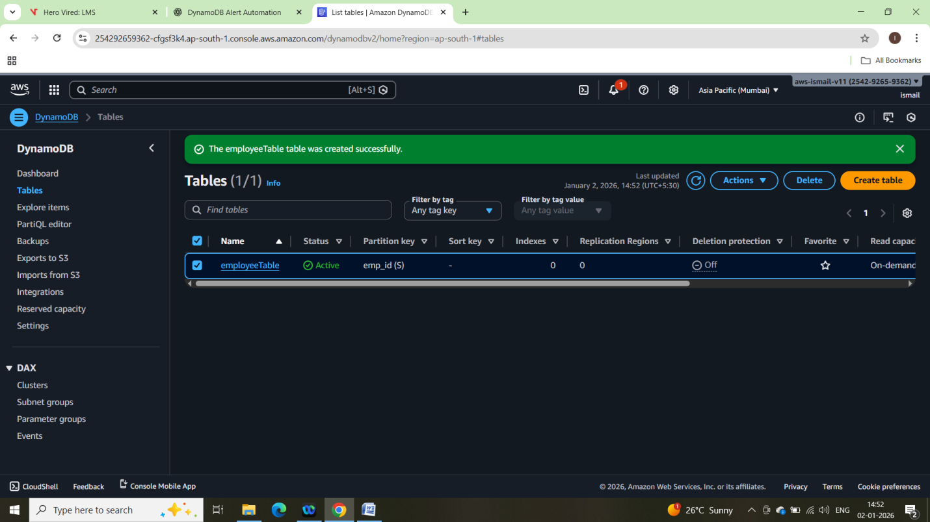

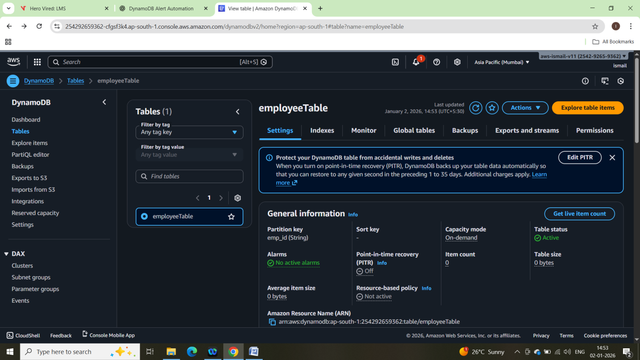

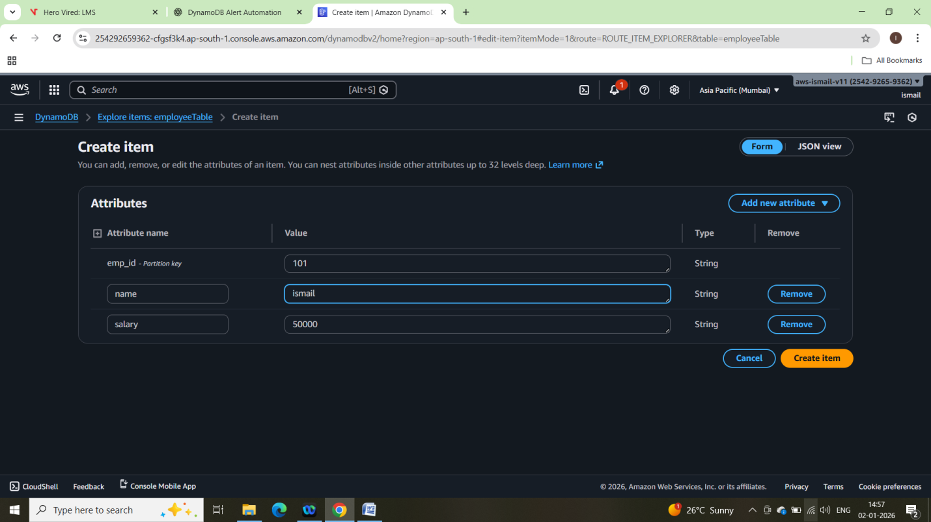

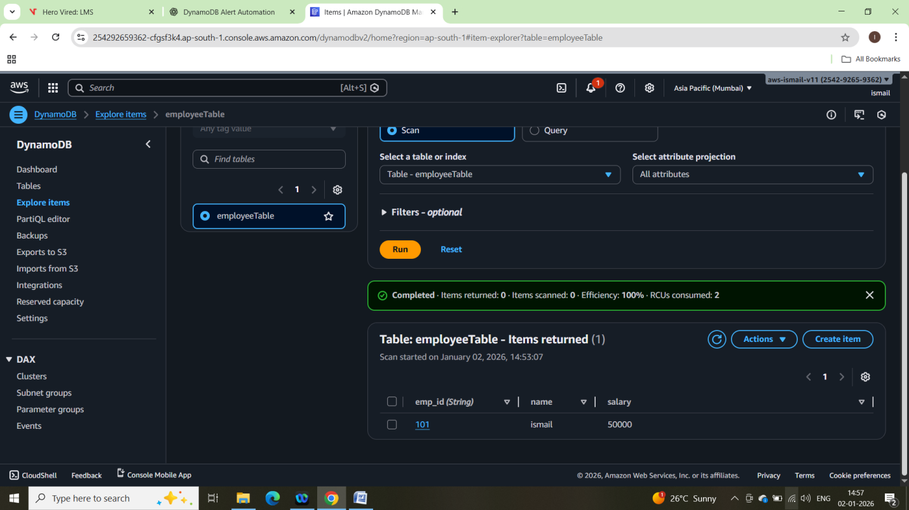

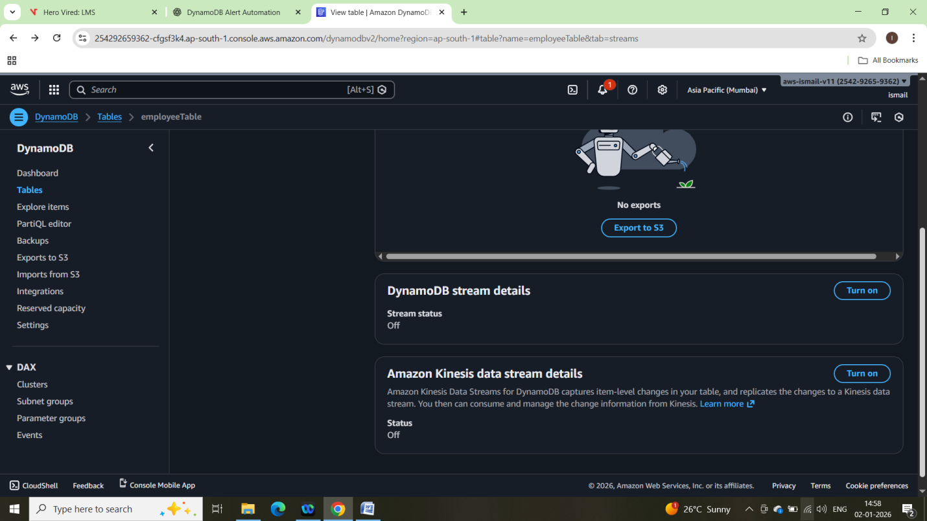

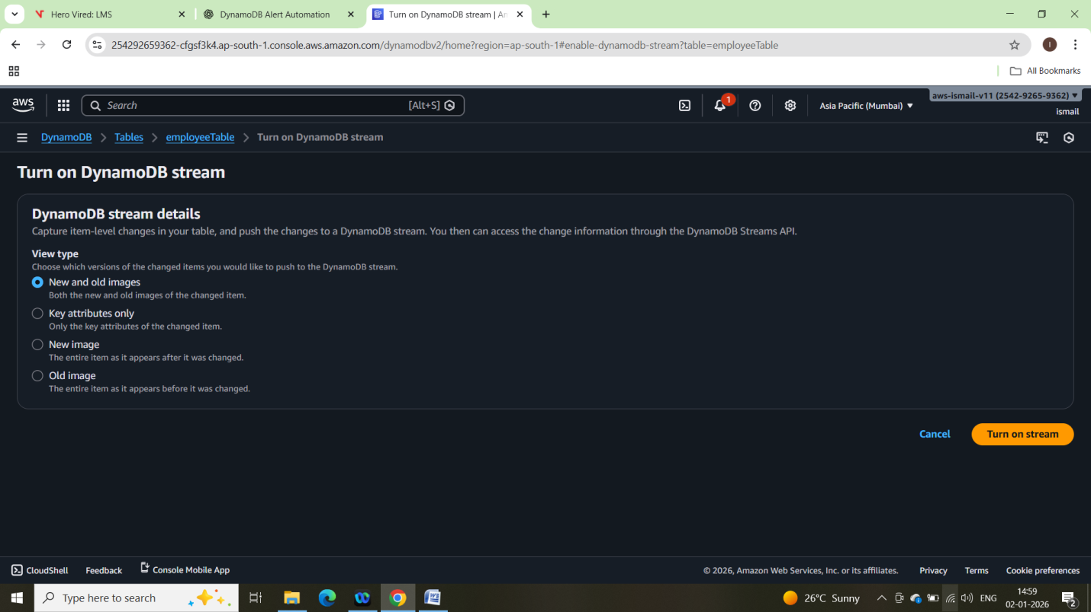

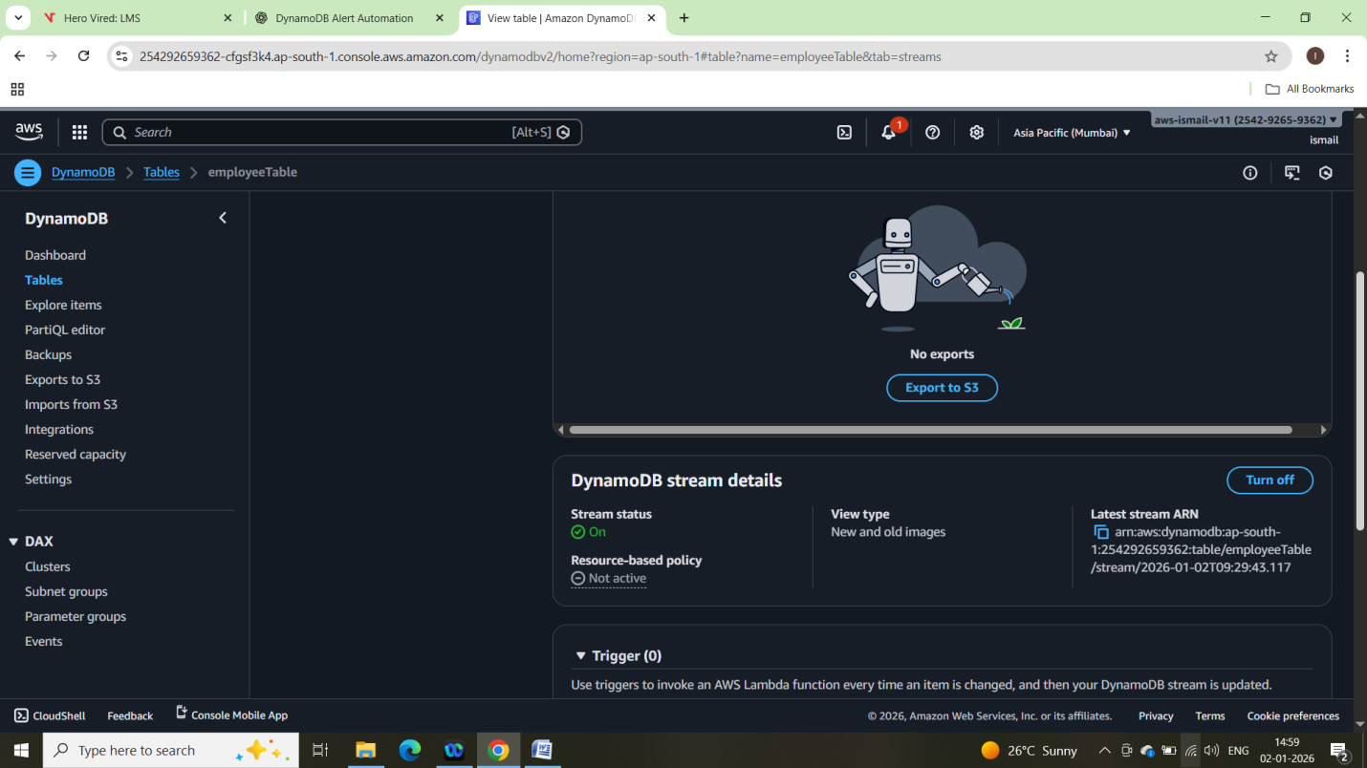

SNS Setup:

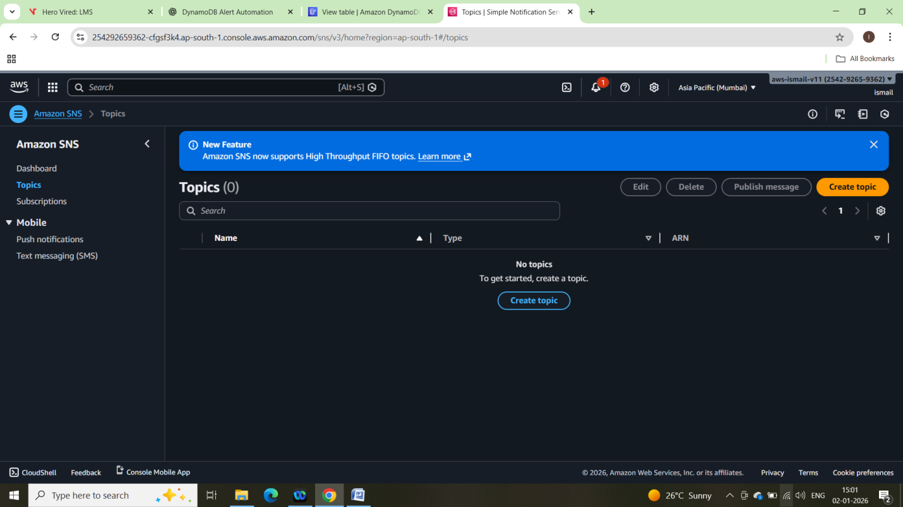

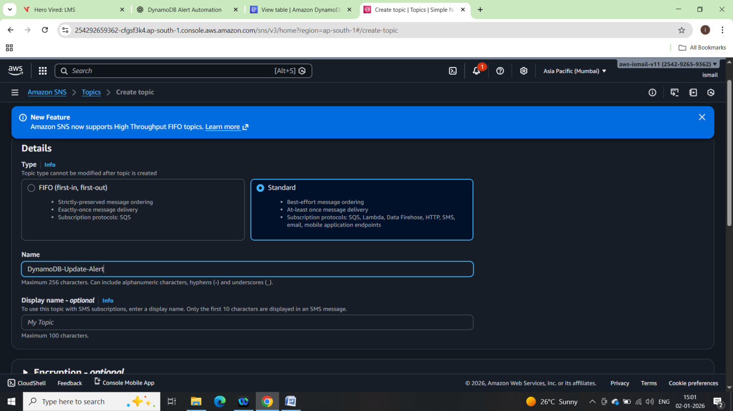

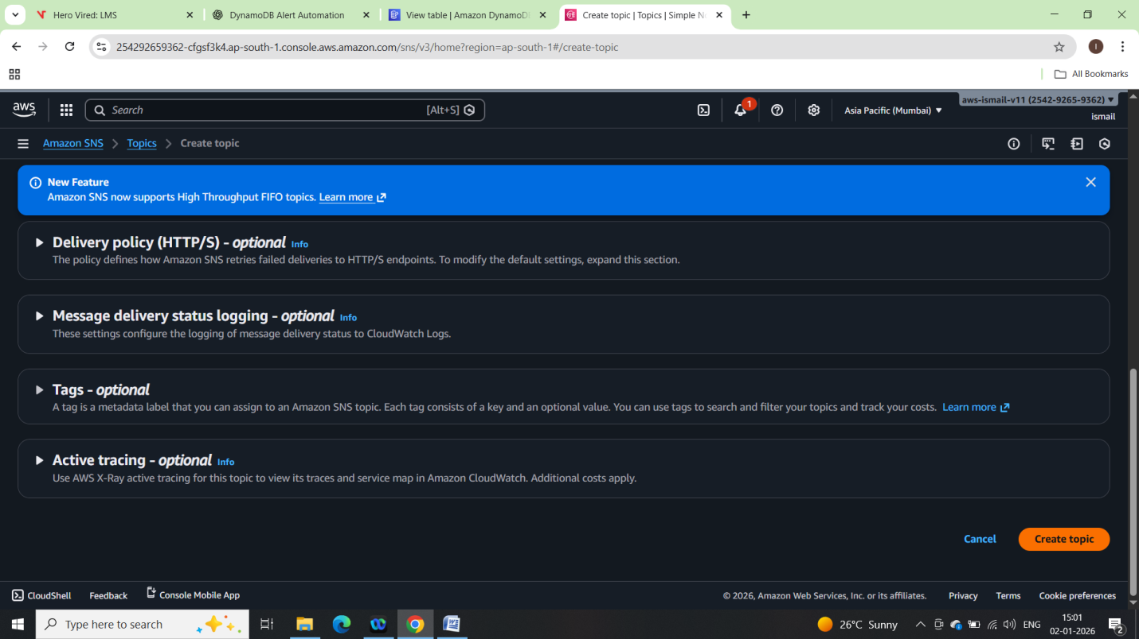

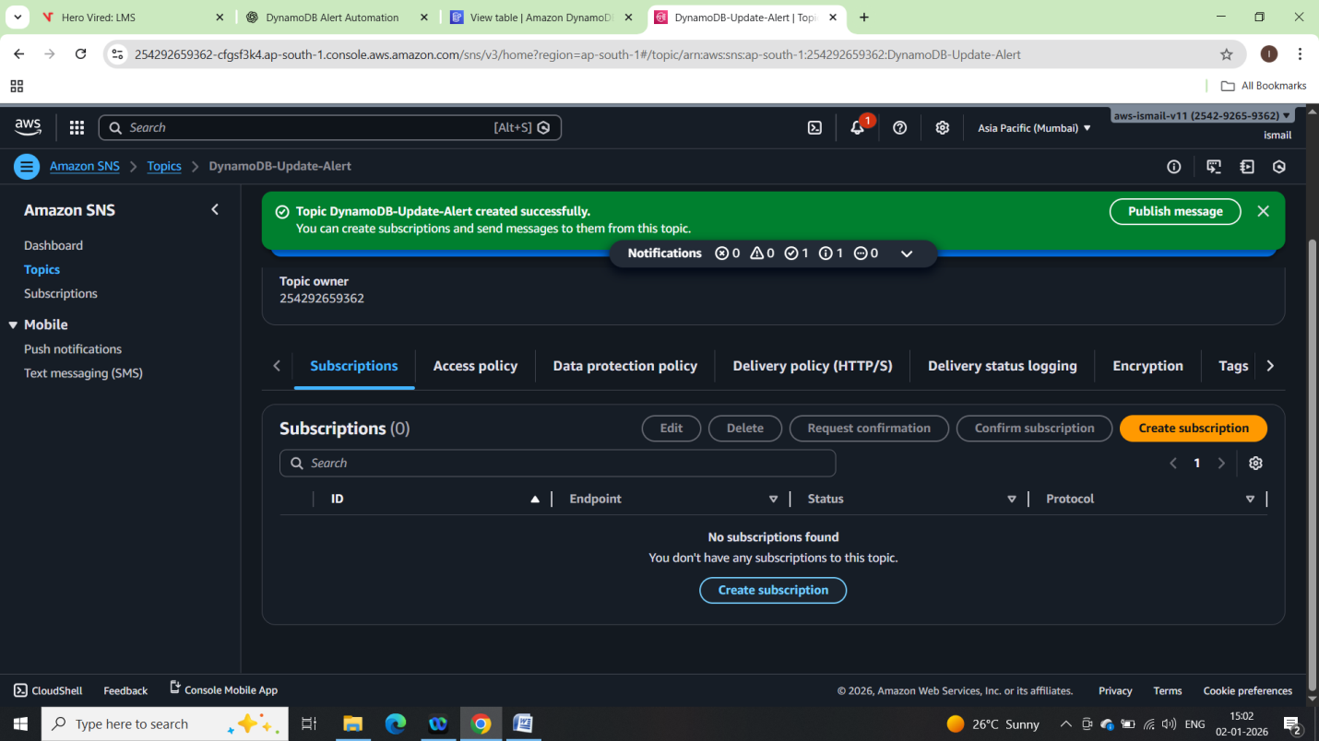

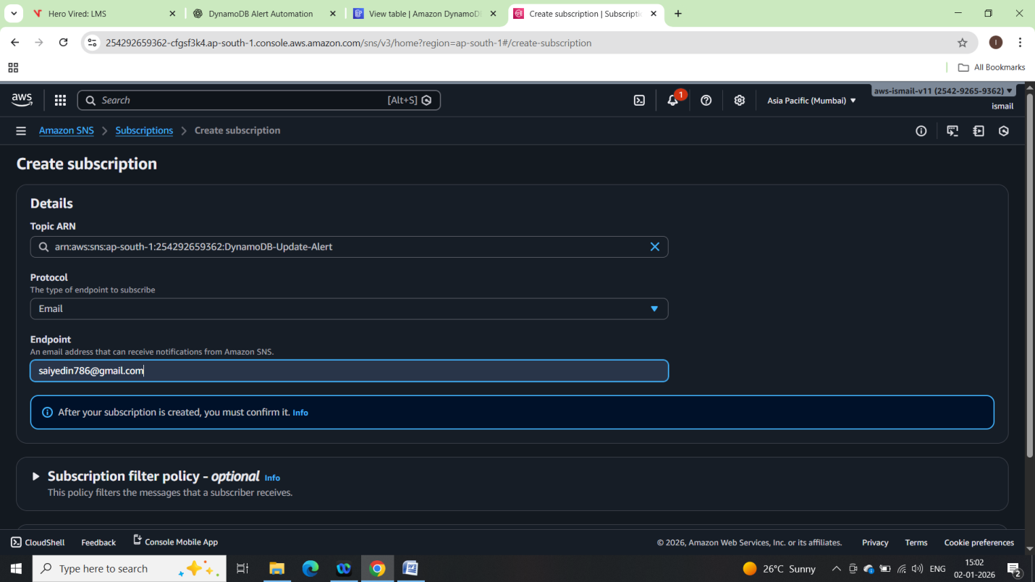

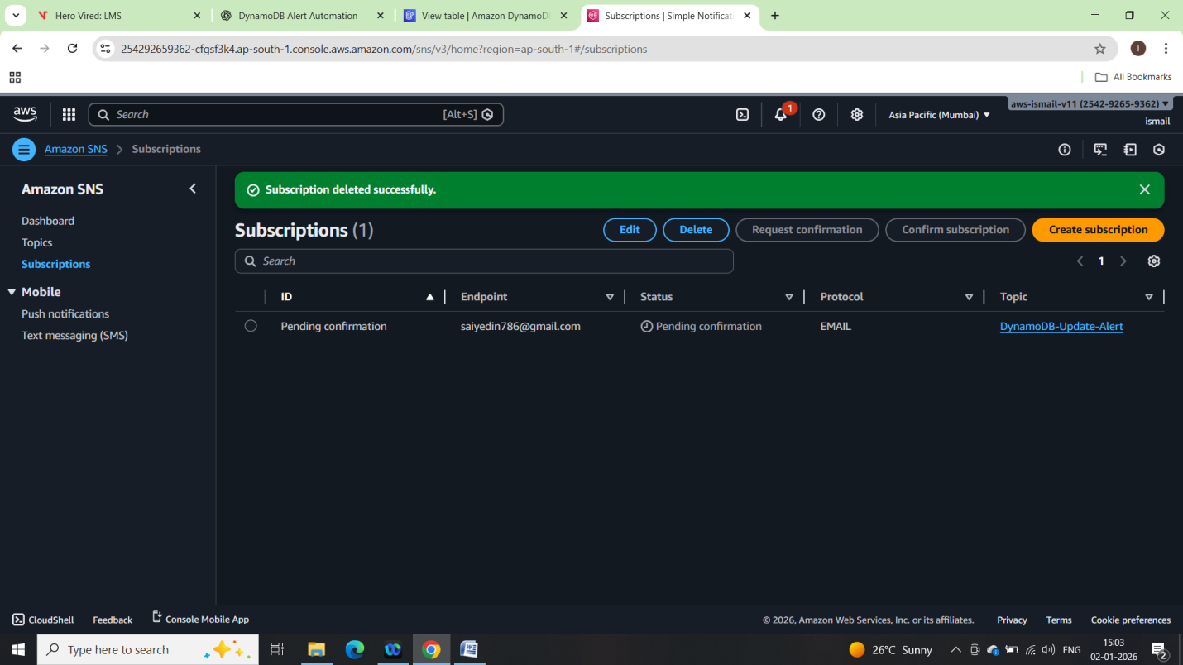

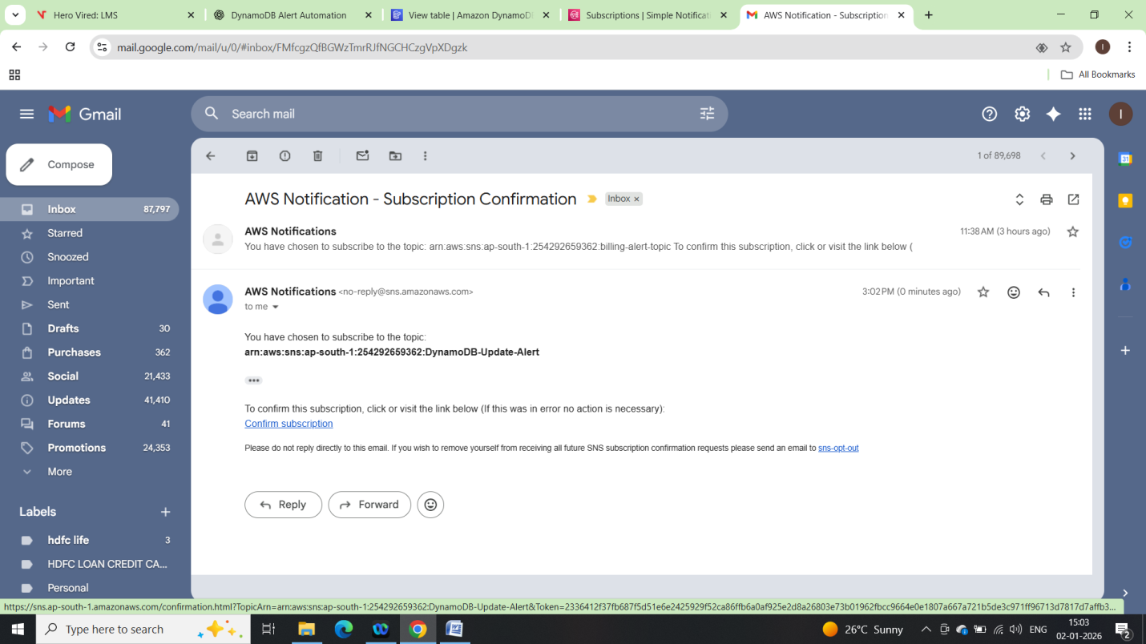

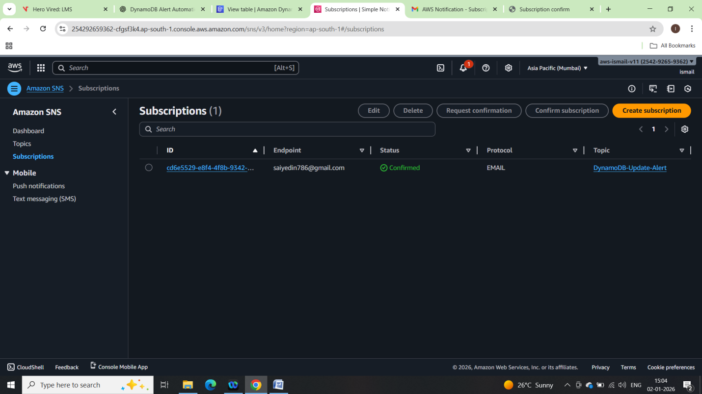

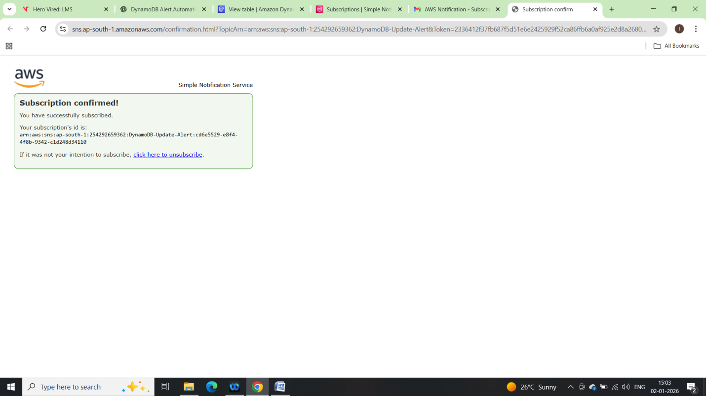

IAM Role for Lambda:

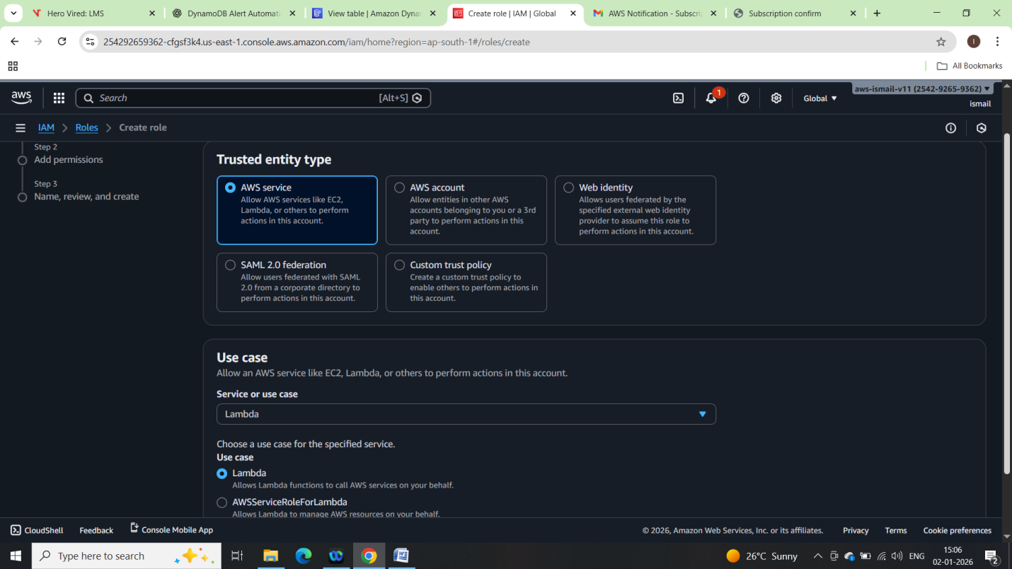

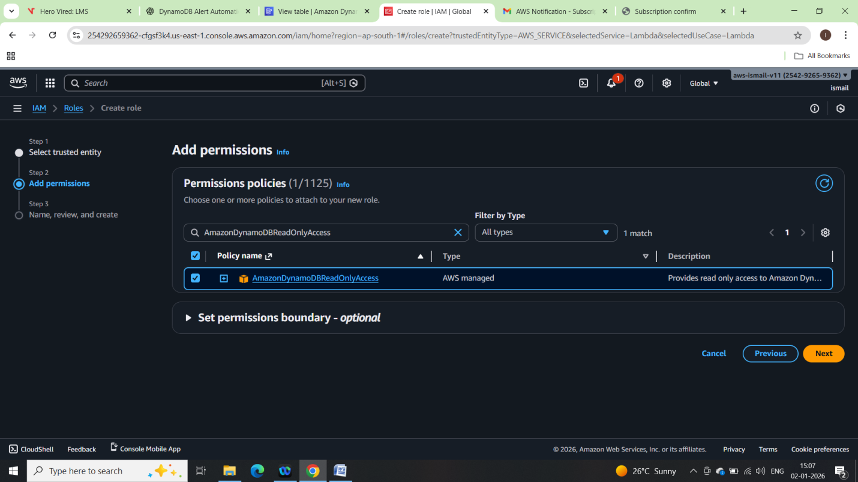

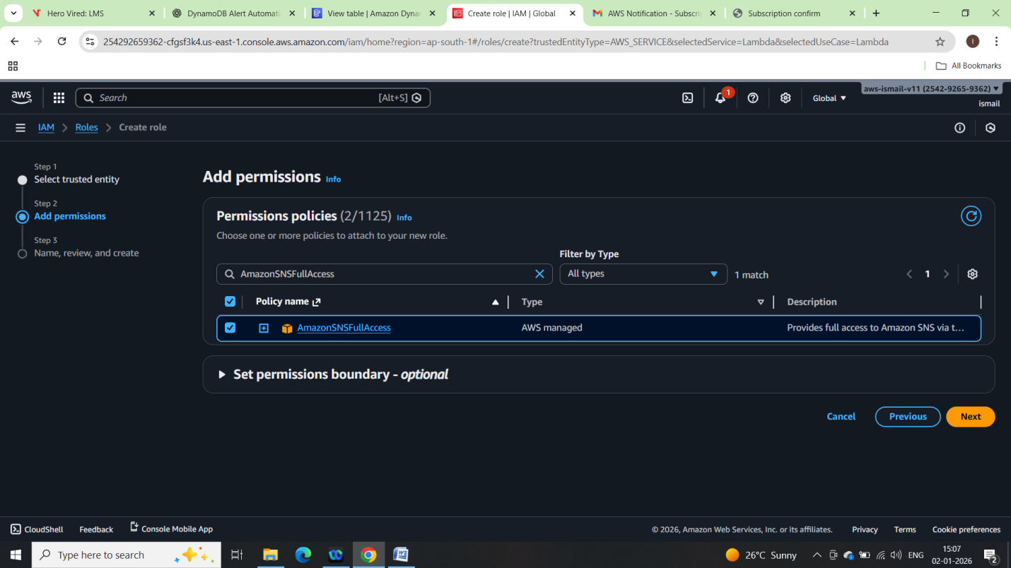

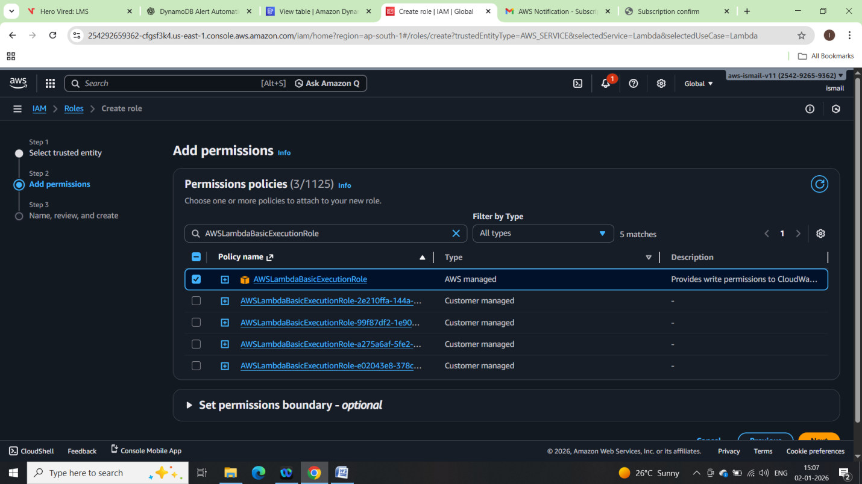

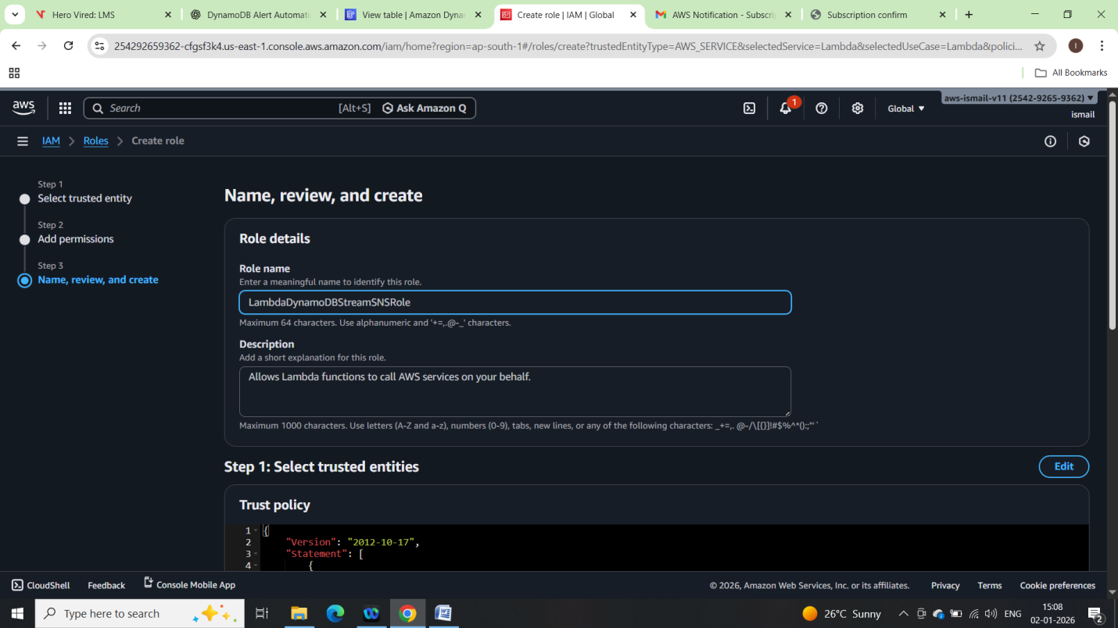

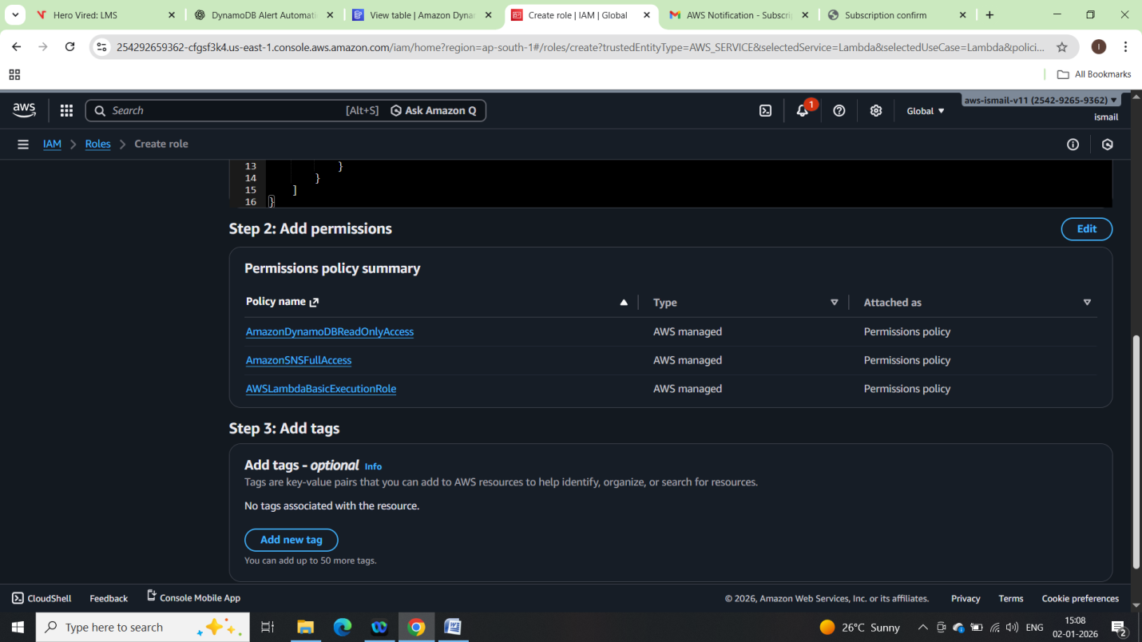

**Lambda Function Creation:**

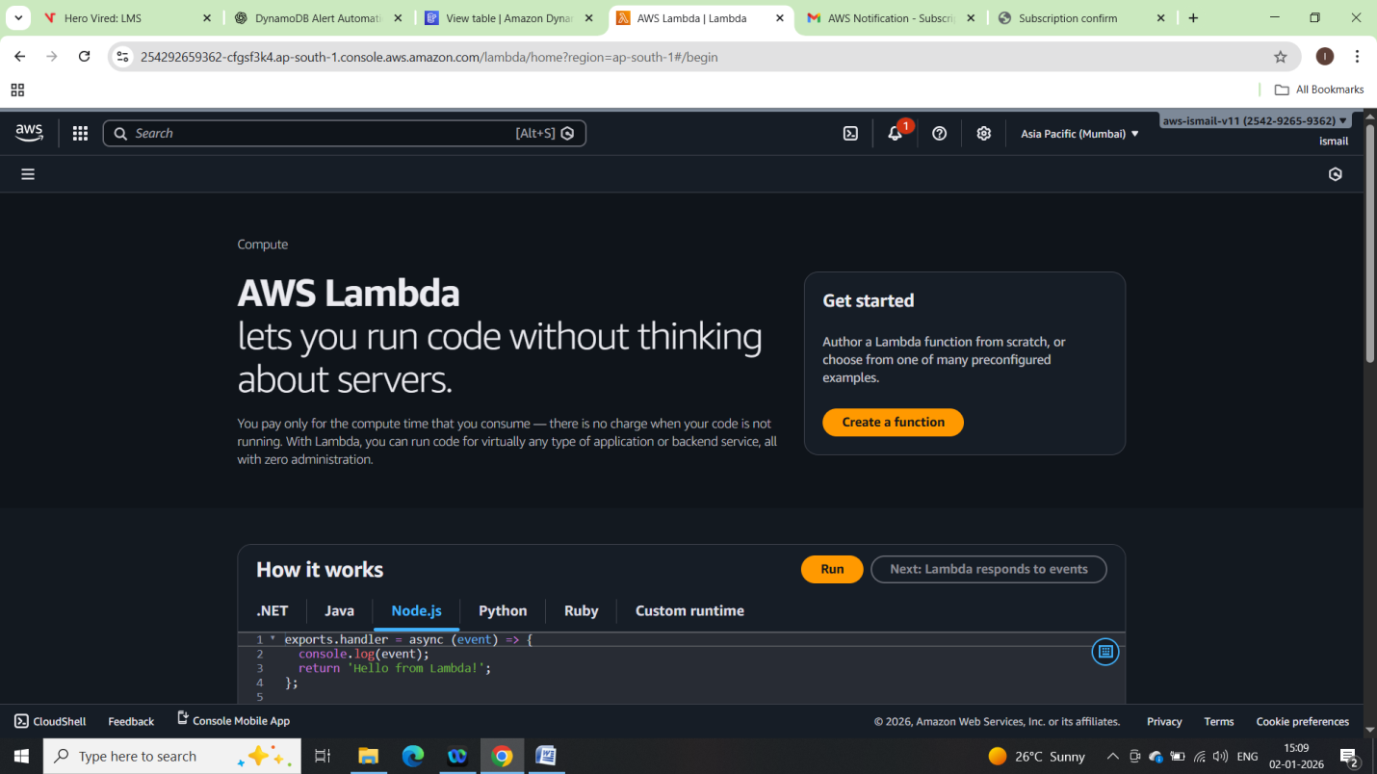

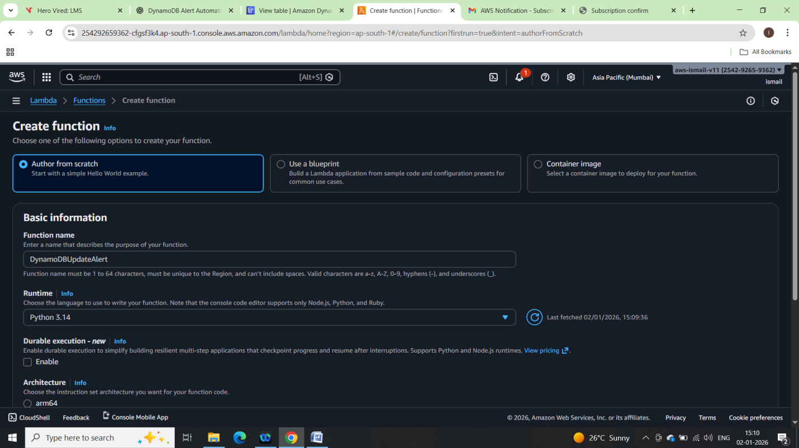

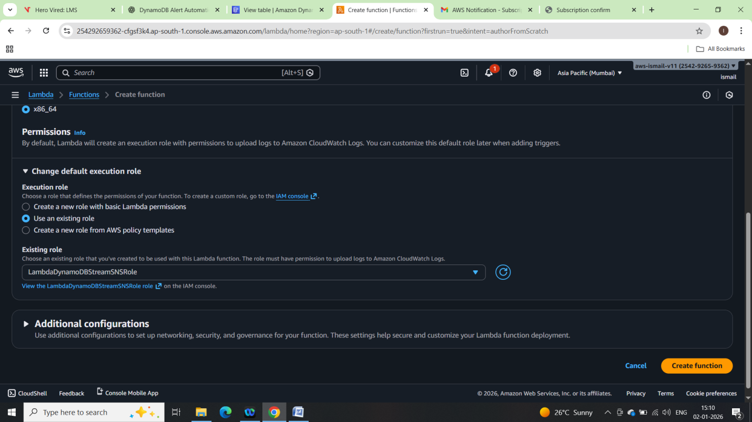

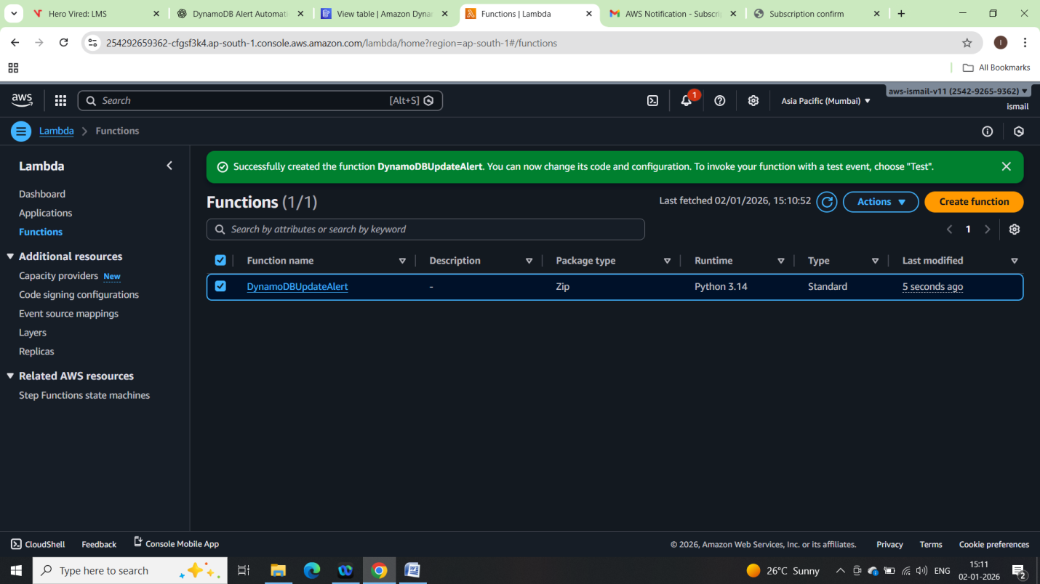

Attach DynamoDB Stream to Lambda:

• Inside Lambda → **Configuration → Triggers**

• Click **Add trigger**

• Select **DynamoDB**

• Choose:

* Table: EmployeeTable
* Batch size: 1
* Starting position: LATEST

• Enable trigger

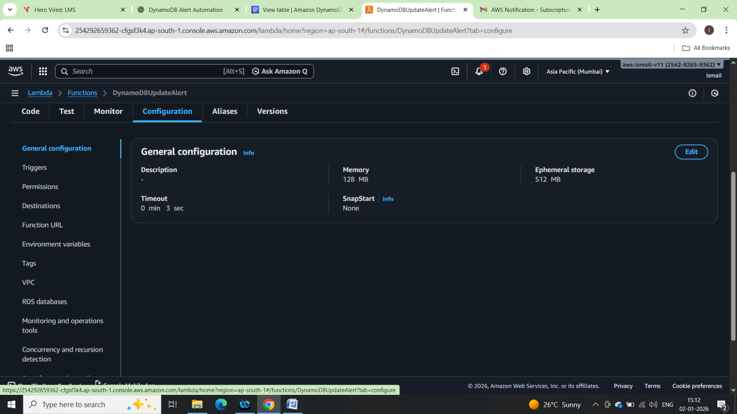

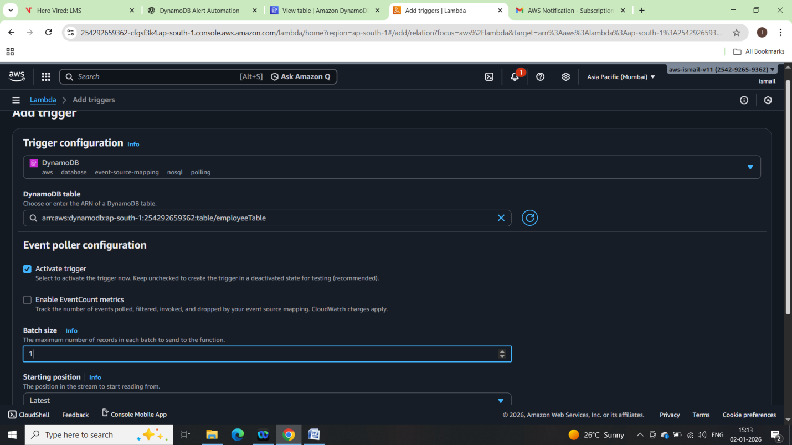

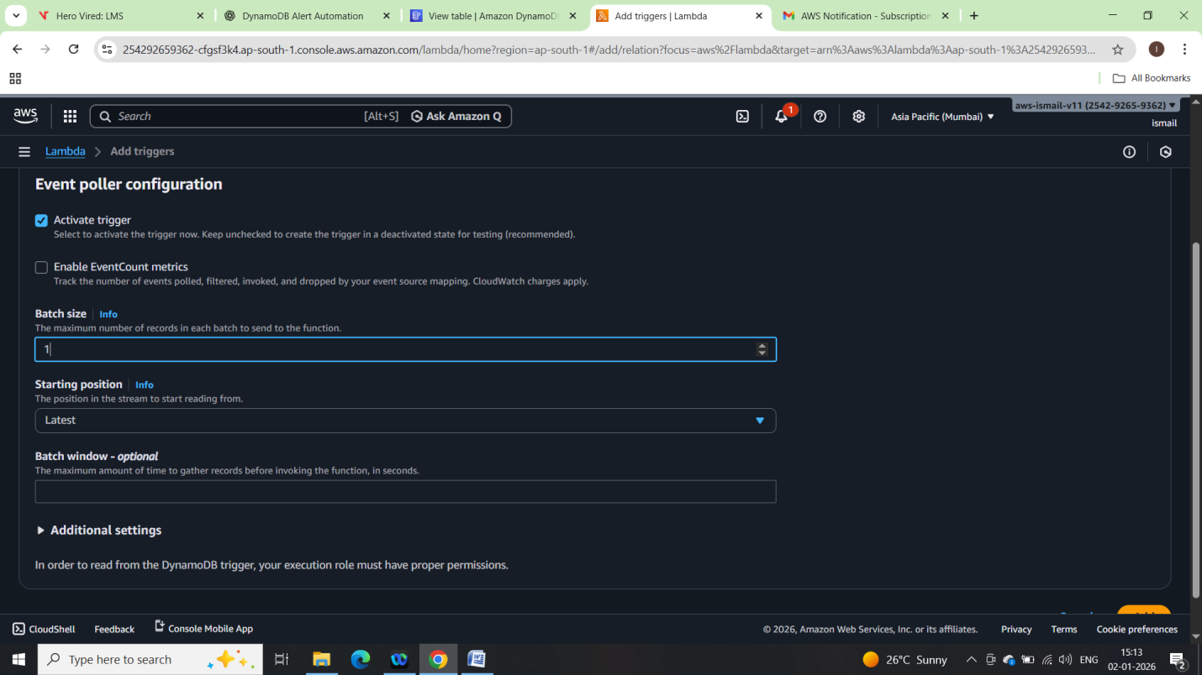

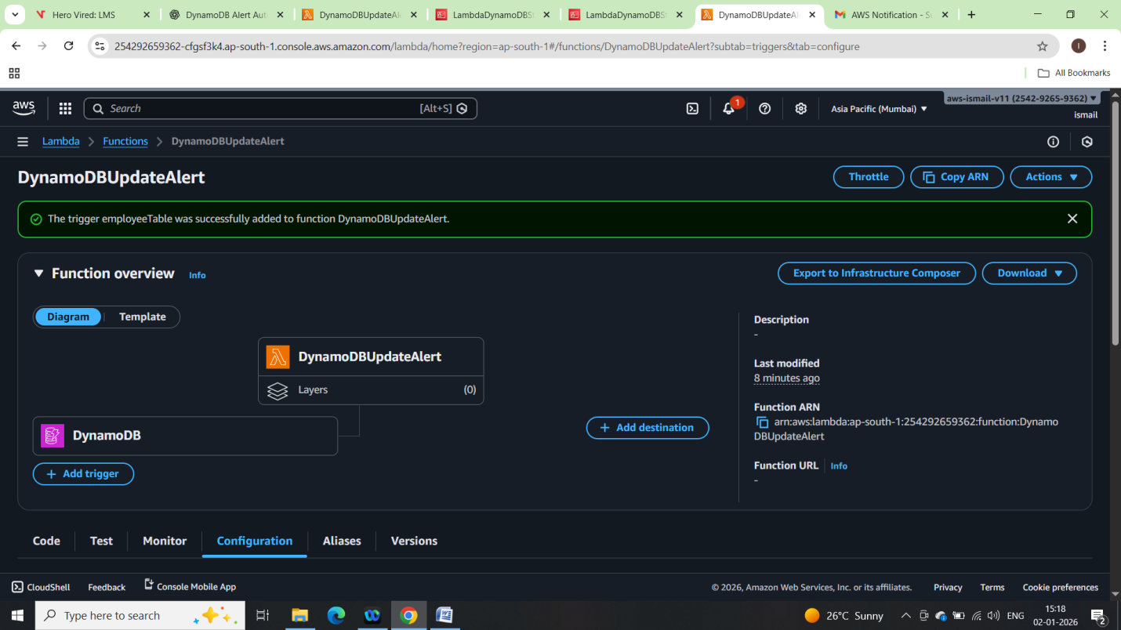

Lamba Function code:

import json

import boto3

sns = boto3.client('sns')

SNS_TOPIC_ARN = "arn:aws:sns:ap-south-1:254292659362:DynamoDB-Update-Alert"

def lambda_handler(event, context):

print("Received event:", json.dumps(event))

for record in event['Records']:

# Process only MODIFY events

if record['eventName'] == 'MODIFY':

old_image = record['dynamodb']['OldImage']

new_image = record['dynamodb']['NewImage']

message = (

"DynamoDB Item Updated\n\n"

f"Old Item:\n{json.dumps(old_image, indent=2)}\n\n"

f"New Item:\n{json.dumps(new_image, indent=2)}"

)

response = sns.publish(

TopicArn=SNS_TOPIC_ARN,

Subject="DynamoDB Item Update Alert",

Message=message

)

print("SNS notification sent:", response)

return {

'statusCode': 200,

'body': 'Processed DynamoDB update event'

}

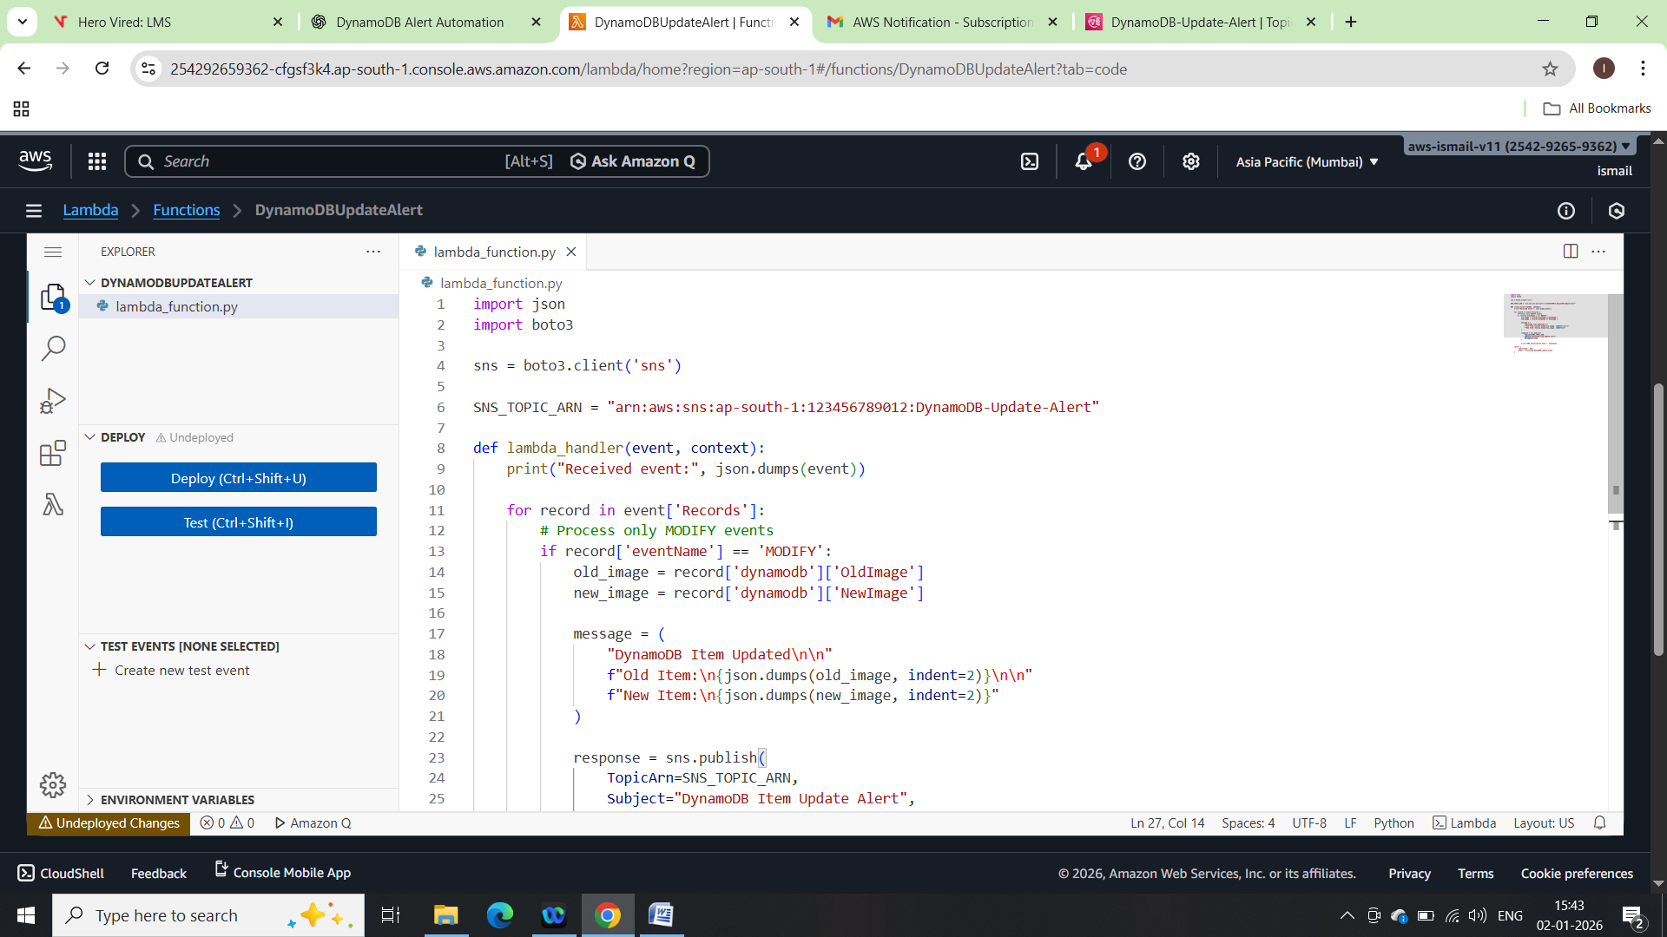

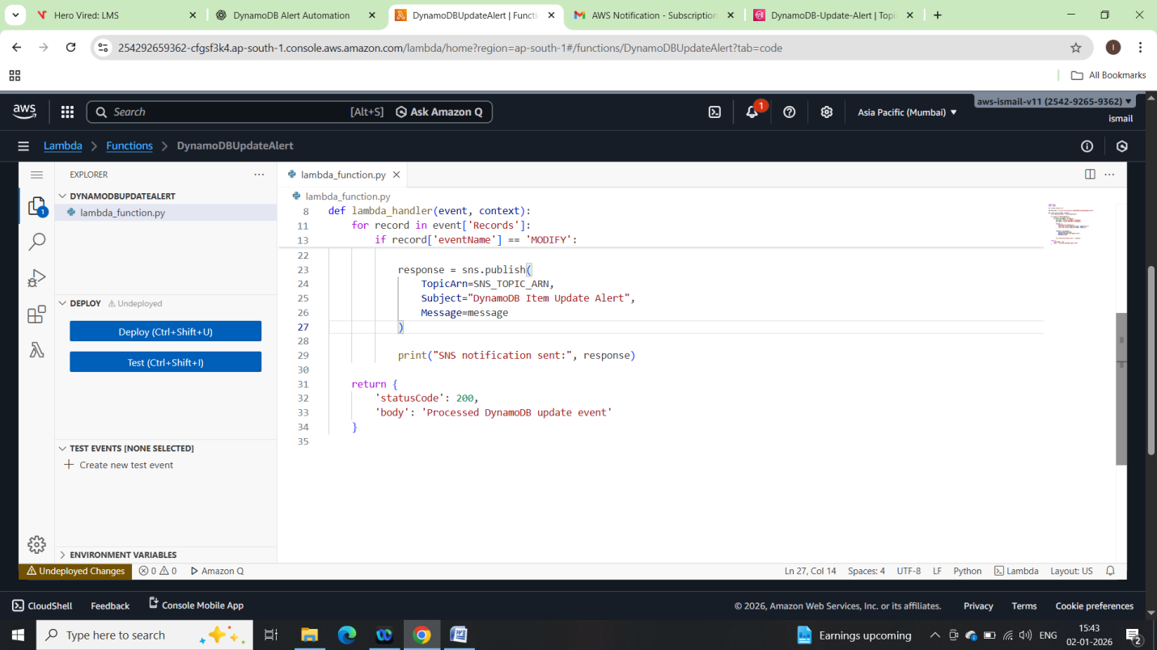

Testing the Setup

• Go to **DynamoDB → EmployeeTable**

• Edit an existing item:

* Change salary from 50000 → 60000

• Save changes

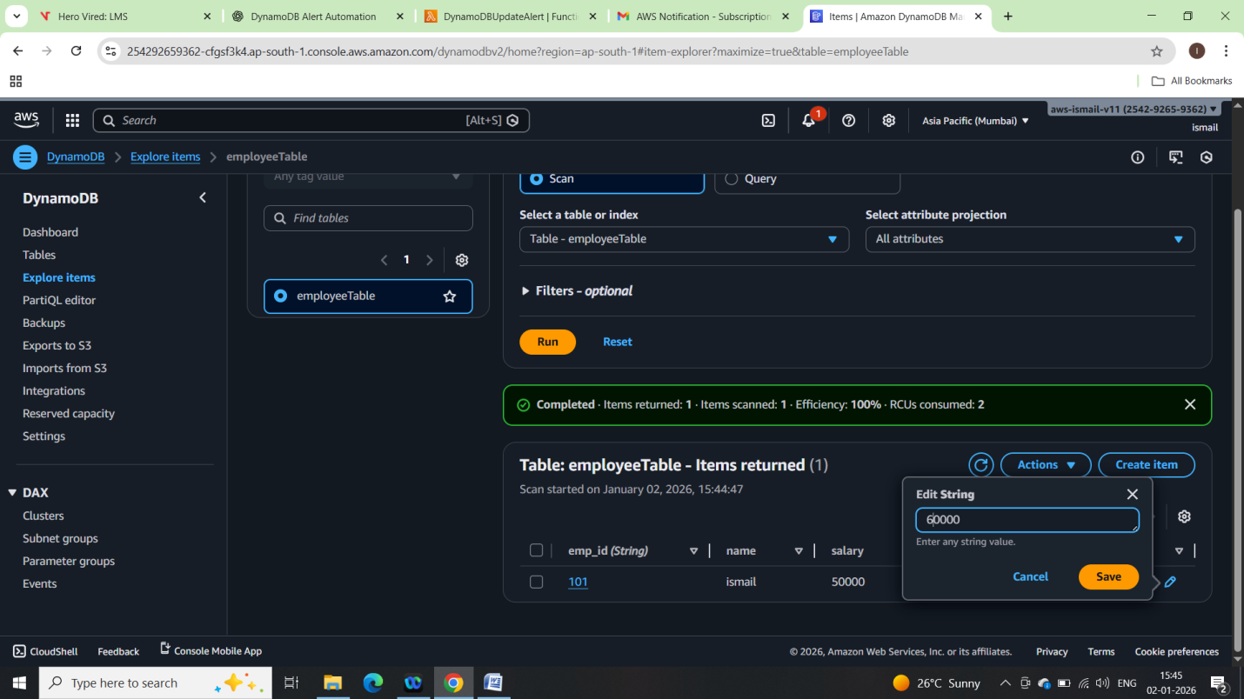

Cloudwatch logs:

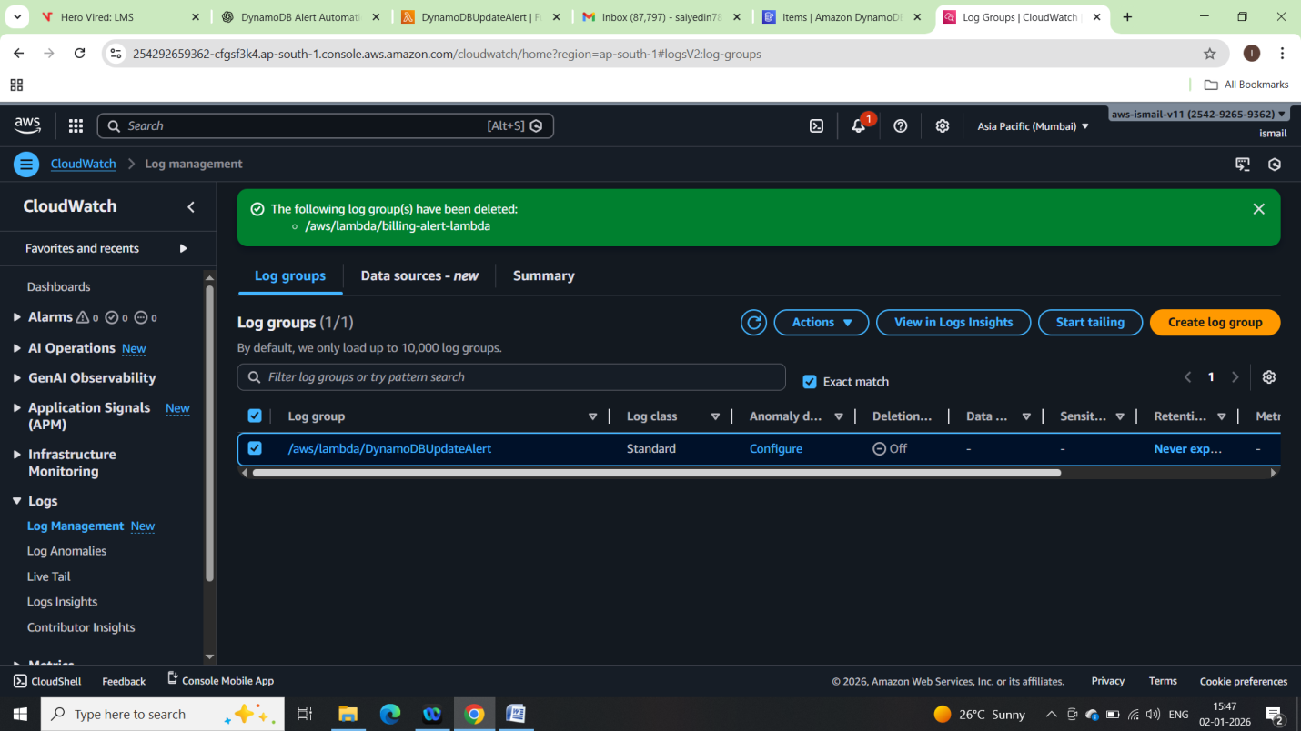

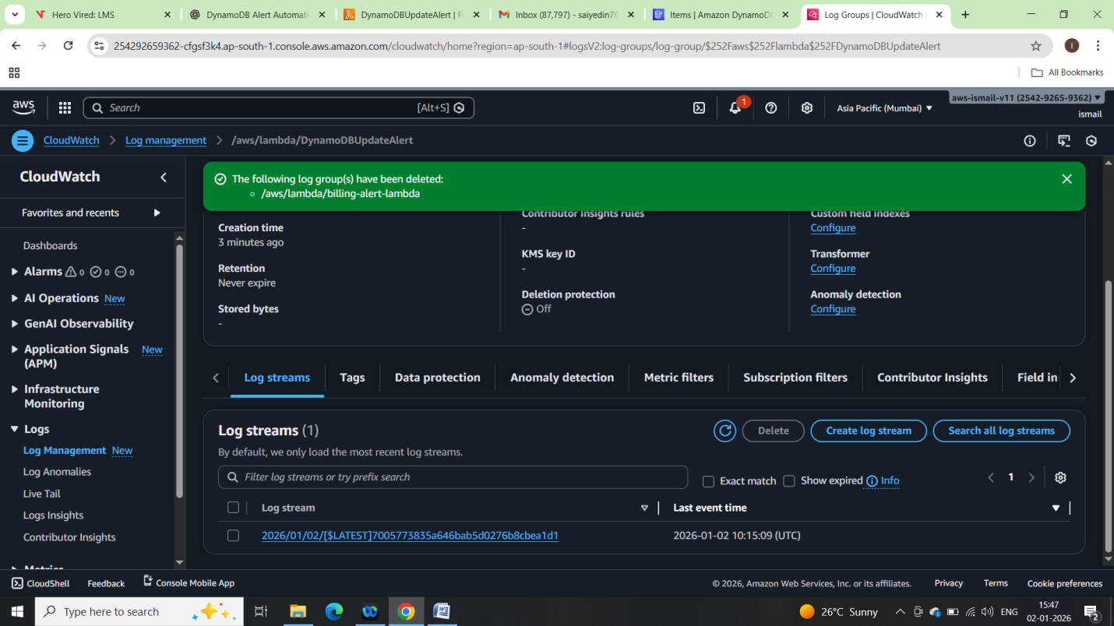

Email received:

